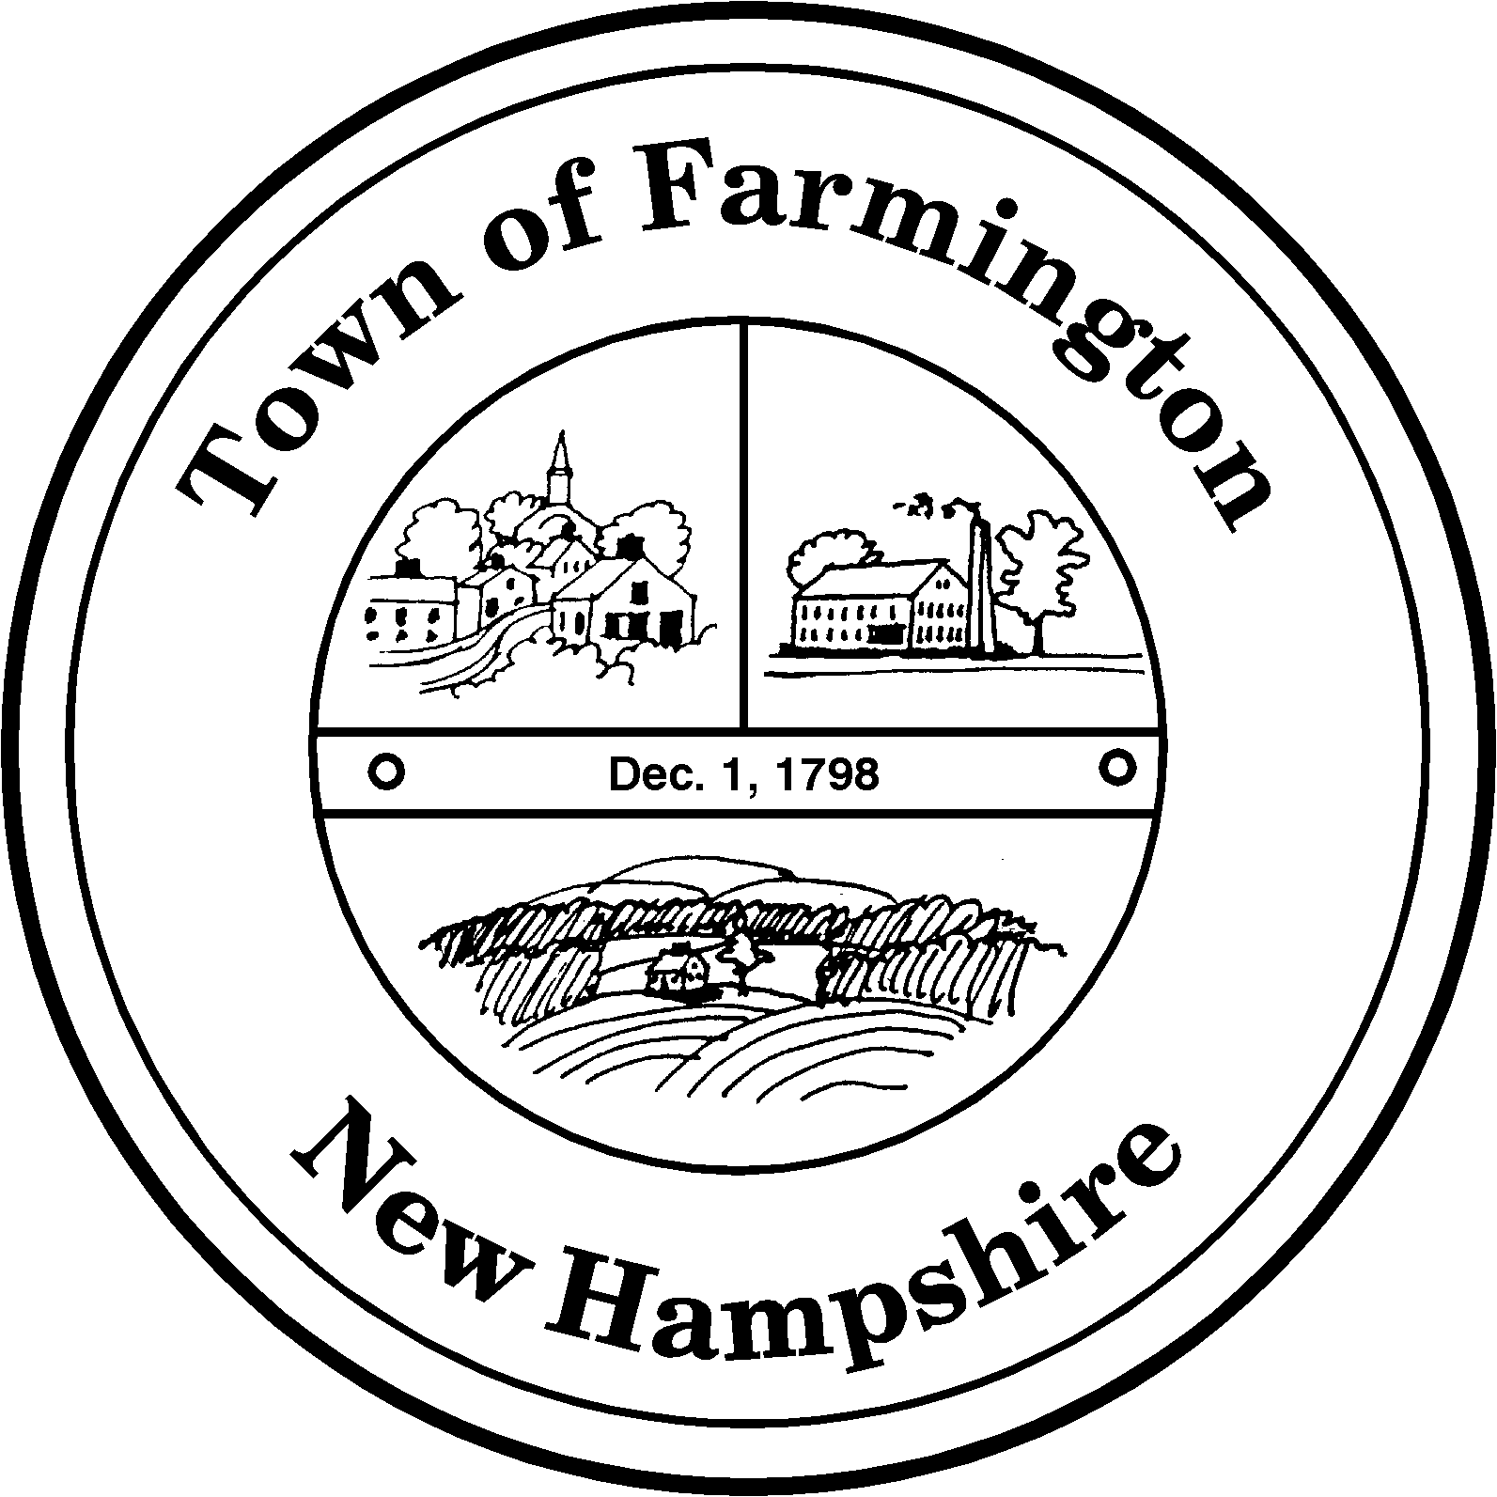
Town of Farmington
Planning and Community Development
356 Main Street
Farmington, NH 03835
Phone: (603) 755-2774
A Bicentennial Community
1798 - 1998

PLANNING BOARD MEETING

TUESDAY – July 19, 2011

356 Main Street - Farmington, NH

AGENDA - 6:00 p. m.

BUSINESS BEFORE THE BOARD:

- Pledge of Allegiance

- Review and approve Meeting Minutes of June 21, 2011

- Continued discussion re: possible zoning amendments for Lancelot Shores

- Continued discussion re: possible zoning amendments for residential neighborhoods impacted by the 2009 Route 11 rezoning.

- Any other business to come before the board.

PUBLIC HEARING 6:30 P.M.

CONTINUED CASES:

None

NEW CASES:

None

Paul Parker, Chairman,

Farmington Planning Board

